BLOCKCHAIN-BASED DIGITAL WILL AND INHERITANCE MANAGEMENT SYSTEM

BACHELOR OF TECHNOLOGY IN
COMPUTER SCIENCE AND ENGINEERING

Use Case Report
submitted by
ABDUL ZAHEDA BEGUM 23501A0502
Under the guidance of
Mr. A. Prashant, Asst. Prof.



Department of Computer Science and Engineering Prasad V Potluri Siddhartha Institute of Technology (Permanently affiliated to JNTU-Kakinada, Approved by AICTE) (An NBA & NAAC accredited and ISO 9001:2015 certified institute) Kanuru, Vijayawada-520 007

2026-27

Prasad V Potluri Siddhartha Institute of Technology (Permanently affiliated to JNTU-Kakinada, Approved by AICTE) (An NBA & NAAC accredited and ISO 9001:2015 certified institute) Kanuru, Vijayawada-520 007

CERTIFICATE

This is to certify that the Use Case report entitled “BLOCKCHAIN-BASED DIGITAL WILL AND INHERITANCE MANAGEMENT SYSTEM” that is being submitted by ABDUL ZAHEDA BEGUM (23501A0502), as part of Assignment-2 for the Blockchain Technology(23CS4701B) course in 4-1 during the academic year 2026-27.

Course Coordinator Mr. A. Prashant Assistant Professor, Department of CSE, PVPSIT, Vijayawada
Head of the Department Dr. A. Jayalakshmi, Professor and Head, Department of CSE, PVPSIT, Vijayawada

MARKS
ASSIGNMENT-2: /5

INDEX

S. No. | Chapter | Page No.
1 | Introduction | 01
2 | Background | 02
3 | Blockchain Basics | 04
4 | Use Case Overview | 06
5 | Implementation | 09
6 | Benefits | 12
7 | Challenges | 14
8 | Conclusion | 15
9 | SDG’s Addressed | 16
10 | References | 17
11 | Appendix A | 18

- INTRODUCTION

1.1 Overview of Blockchain Technology

Blockchain technology is a distributed digital ledger that records transactions in a verifiable and tamper-resistant manner. It stores records in blocks that are linked using cryptographic hashes. Once a transaction is confirmed, modifying the recorded history becomes difficult, depending on the blockchain network and its security model.
Blockchain can support applications that require secure record keeping, transparency, and verification. It is used in areas such as finance, supply chain management, healthcare, identity management, and digital asset tracking.
Smart contracts are programs deployed on a blockchain that execute predefined rules when specified conditions are satisfied. They can automate operations, enforce permissions, and record important actions without requiring every step to be handled manually.

1.2 Relevance of Blockchain in Digital Will and Inheritance Management

Traditional will management may involve physical documents, legal records, executors, family members, and financial institutions. Documents can be misplaced, unauthorized modifications may occur, and disagreements can arise over the authenticity or latest version of a will.
A blockchain-based digital will management system aims to address these problems by maintaining verifiable records of will registration, document integrity, authorization, and inheritance-related activities.
The proposed system allows a Testator to create a digital will, specify beneficiaries, manage asset information, and upload supporting documents. Cryptographic hashing can be used to detect changes in documents, while smart contracts can enforce selected rules and record important transactions.
The system also supports authorized verification, inheritance execution workflows, and beneficiary claims. Role-based access control helps ensure that users can perform only the operations permitted to their roles.
However, blockchain records alone do not establish the legal validity of a will. Legal requirements, death verification, ownership confirmation, and actual asset transfers may still require authorized institutions and applicable legal procedures.

1.3 Objectives of the Project

The main objectives are:
- To provide a digital platform for creating and managing wills.
- To maintain a verifiable record of will registration and version history.
- To protect supporting documents through encryption and integrity verification.
- To define beneficiaries and record their inheritance allocations.
- To use smart contracts to enforce selected access and execution rules.
- To provide an authorized death-verification workflow.
- To enable beneficiaries to view eligible inheritance information and submit claims.
- To maintain traceable records of important system activities.
- BACKGROUND

Traditional will management can involve several challenges because sensitive documents and inheritance decisions must be handled carefully.

2.1 Loss or Damage of Documents

Physical wills, supporting records, and ownership documents can be lost, damaged, or stored in locations that are difficult to access. Retrieving the correct document may delay the inheritance process.
A digital document management system can improve availability and organization, provided appropriate backups and security controls are maintained.

2.2 Unauthorized Modification of Wills

If document storage relies entirely on a centralized system, unauthorized changes may be difficult to detect without suitable integrity controls and audit records.
Blockchain transaction history and cryptographic document hashes can help identify changes and provide evidence of previously recorded information.

2.3 Disputes Between Beneficiaries

Beneficiaries may disagree about asset allocation, the latest will version, or whether the conditions for inheritance have been satisfied.
A system that maintains version records, beneficiary allocations, verification decisions, and transaction history can improve traceability. It cannot eliminate every legal dispute.

2.4 Difficulties in Death Verification

Inheritance processing usually requires reliable confirmation that the Testator has died. Incorrect or unauthorized verification could lead to serious consequences.
The system therefore restricts verification actions to authorized Verifier accounts. In the current prototype, this is a demonstration workflow rather than a connection to government or hospital databases.

2.5 Privacy of Sensitive Documents

Wills can contain personal, financial, and family information. Storing this information openly on a public blockchain could expose it permanently.
The proposed system uses encrypted document uploads and hash verification. Sensitive document contents should remain off-chain, and access must be restricted to authorized users.

2.6 Unauthorized Access

An unauthorized person may attempt to view a will, modify beneficiary information, approve verification, or review claims.
Authentication, server-side authorization, smart-contract access control, and audit records help reduce these risks.

2.7 Complexity of Inheritance Processing

Inheritance can involve multiple steps, including document review, death verification, beneficiary confirmation, legal checks, and claim processing.
The system organizes these activities into a structured digital workflow. Automation can reduce administrative effort, but legal and institutional processes cannot be replaced entirely by software.

2.8 Need for a Secure Digital System

These challenges create a need for a system that combines document integrity, access control, traceable transactions, and structured inheritance workflows. Blockchain and smart contracts can support these objectives when implemented with suitable privacy, security, and legal safeguards.

- BLOCKCHAIN BASICS

3.1 Decentralization

Decentralization means that a blockchain network does not necessarily depend on a single central authority to maintain its transaction history. Depending on the network design, multiple nodes can participate in validating and maintaining records.
The current project uses a local Hardhat blockchain, which is primarily intended for development and testing. It should not be described as a live decentralized production network.

3.2 Immutability

Blockchain records are designed to resist unauthorized alteration through cryptographic linking, transaction validation, and consensus mechanisms.
In the proposed inheritance system, blockchain records can provide a traceable history of selected will-related actions. This helps identify changes and makes retrospective manipulation more difficult.
Immutability does not guarantee that information entered originally was correct or legally valid.

3.3 Transparency and Traceability

Blockchain transactions and contract events can provide an audit trail of actions such as registering a will, updating its state, approving verification, and executing an inheritance workflow.
Access to these records depends on the blockchain and application design. Sensitive personal information should not be exposed unnecessarily.

3.4 Smart Contracts

Smart contracts are programs that execute predefined rules on a blockchain. They can validate inputs, enforce role restrictions, update contract state, and emit events.
In this project, the WillRegistry contract is used as part of the will-management workflow. Related contract functionality can support authorization, inheritance execution, and traceable state changes.
Smart contracts do not independently verify real-world facts such as death, legal ownership, or the validity of a signed will. These facts require trusted evidence or external verification processes.

3.5 Consensus Mechanisms

Consensus mechanisms allow blockchain participants to agree on the order and validity of transactions.
Public blockchains may use Proof of Stake or other consensus protocols. Permissioned networks may use different protocols suited to known participants.
The current prototype runs on a local Hardhat development network with chain ID 31337. It should not be described as using a production consensus network. A permissioned blockchain such as Hyperledger Fabric could be evaluated for a future deployment involving authorized institutions.

3.6 Cryptographic Security

Cryptographic techniques protect blockchain operations and help verify the integrity of digital records.
The project uses document hashing to identify changes in uploaded files and encryption to protect documents. Hashing and encryption serve different purposes:
- Hashing: Produces a fixed-length digest used to verify integrity.
- Encryption: Protects the confidentiality of information.
- Digital signatures and wallet authorization: Can help establish control over blockchain accounts and authorize transactions.
The security of the overall system also depends on key management, authentication, access controls, application security, and database protection.

4. USE CASE OVERVIEW

4.1 Objectives

The main objective of the Blockchain-Based Digital Will and Inheritance Management System is to provide a secure and traceable platform for managing digital wills and inheritance-related workflows.
The system aims to:
- Digitize will creation and record management.
- Maintain verifiable will records and version history.
- Detect document modification through hash verification.
- Manage beneficiaries and inheritance allocations.
- Restrict sensitive operations to authorized roles.
- Record verification and inheritance-related transactions.
- Provide a structured beneficiary claim process.
- Improve accountability through blockchain events and audit history.

4.2 Scope of the System

The system includes the following users and components.
1. Testator
The Testator creates a will, enters asset and beneficiary information, manages allocations, and uploads supporting documents.
2. Beneficiary
A Beneficiary views the inheritance information they are authorized to access and submits or tracks eligible claims.
3. Verifier
The Verifier reviews the demonstration verification request and performs authorized verification actions.
4. Administrator
The Administrator manages permitted system roles and supports application administration.
5. Executor, if enabled
An Executor may assist with inheritance-related tasks if that role is implemented and authorized by the application.
6. Blockchain Network
The local blockchain records smart-contract transactions and events associated with supported operations.
7. Database and Document Storage
Prisma and SQLite maintain application records. Supporting documents are handled through the project's encrypted upload and hash-verification workflow.

4.3 System Architecture

The architecture consists of four major layers.

4.3.1 User Layer
This layer includes the Testator, Beneficiary, Verifier, and Administrator.
Each user interacts with the system according to their role. Role-specific workspaces display the features available to that user.

4.3.2 Web Application Layer
The web application is developed using Next.js, React, TypeScript, and Tailwind CSS.
It provides the user interface for:
- Authentication and role-specific dashboards.
- Will creation and management.
- Beneficiary and allocation management.
- Document uploads and integrity verification.
- Verification requests.
- Inheritance execution and beneficiary claims.
- Displaying transaction and audit information.

4.3.3 Smart Contract Layer
The Solidity smart contract layer contains the on-chain logic for supported will-management operations.
The WillRegistry contract provides the main will-registry functionality. Contract methods and events help record relevant operations and enforce the access rules implemented in the contract.

4.3.4 Database and Storage Layer
Prisma and SQLite support off-chain application data. The document workflow uses encryption and hash verification to help protect uploaded files and detect modification.
Separating sensitive document contents from blockchain records helps avoid placing confidential information directly on-chain.

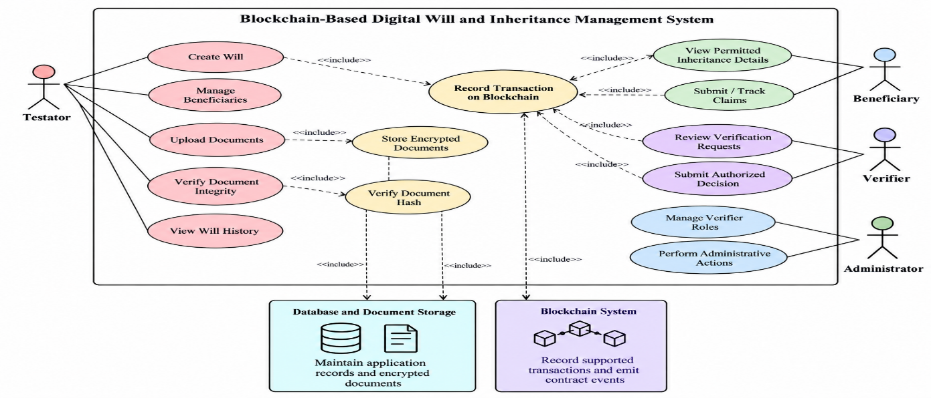
4.4 Use Case Diagram Description
4.5 State Diagram for Functionalities
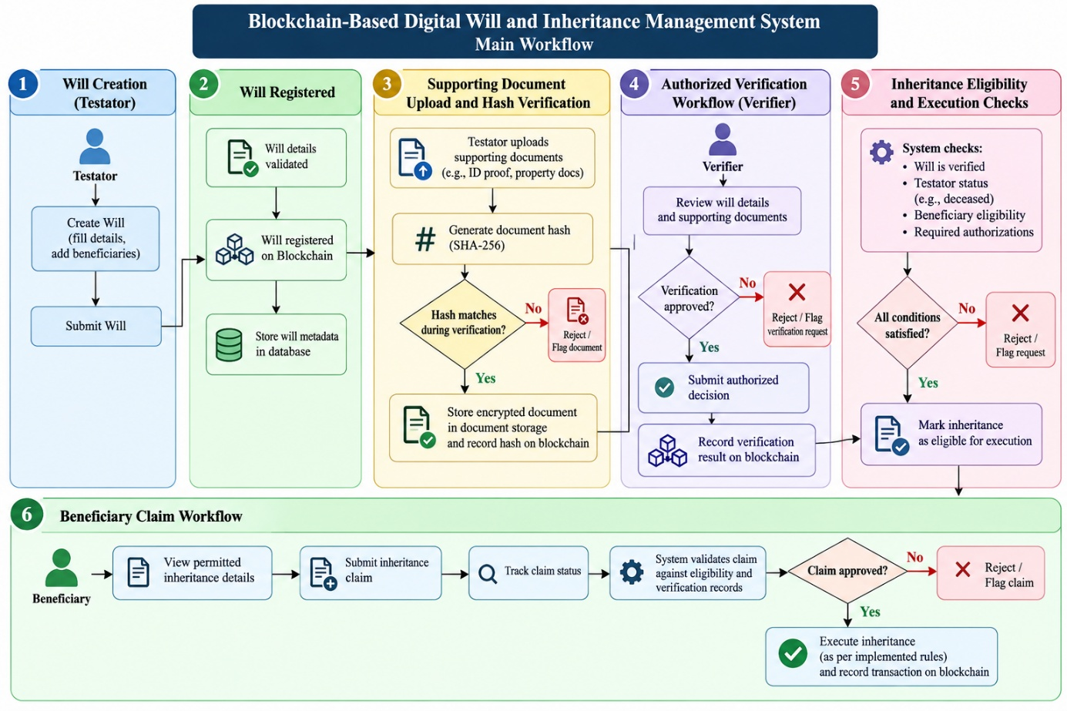

4.6 Workflow of the System

The workflow begins when the Testator signs in and creates a digital will. Beneficiaries and allocations are entered and validated before the will is registered.
Supporting documents can then be uploaded through the encrypted document workflow. The system calculates a hash to verify document integrity.
When inheritance processing is required, an authorized Verifier reviews the demonstration verification request. Once the required conditions are satisfied, the appropriate inheritance operation can be executed through the implemented workflow.
Beneficiaries can then view eligible inheritance information and submit or track claims. Contract events and application records help maintain a traceable history of important operations.
Important: This workflow is a digital prototype. It does not automatically establish legal validity or transfer real property, bank balances, or other external assets.

5. IMPLEMENTATION

5.1 Setting Up the Development Environment

The project uses the following technologies:
Component | Technology | Purpose
Frontend | Next.js, React, TypeScript, Tailwind CSS | User interface and role-based workspaces
Smart contracts | Solidity | On-chain rules and will-registry operations
Blockchain development | Hardhat | Local blockchain, deployment, and contract testing
Blockchain interaction | Ethers.js | Connecting the application to contract operations
Database | SQLite | Off-chain application data
Database access | Prisma | Schema management and database queries
Document security | Encryption and SHA-256 hashing | Confidentiality and integrity verification
The application is tested on a local Hardhat network using chain ID 31337.

5.2 Defining Smart Contracts

5.2.1 Will Registry Contract
The WillRegistry contract forms a core part of the blockchain layer. It supports the registration and management of will-related records according to its implemented functions.
The contract is intended to enforce selected rules and create a traceable record of supported operations.
The exact state variables, function names, and permissions should be documented from the deployed source code rather than assumed from a generic design.

5.2.2 Will Registration
The Testator enters the required information through the application. The application validates the input and submits the relevant operation to the smart contract.
Once the transaction succeeds, the application can display the resulting status and transaction information.

5.2.3 Beneficiary Management

The application allows beneficiary information and inheritance allocations to be managed according to the implemented rules.
The allocation validation should ensure that the total allocation satisfies the project's requirements. Invalid entries should be rejected before they can lead to an inconsistent inheritance record.

5.2.4 Inheritance Execution
The inheritance workflow checks the conditions required for execution. Authorization and state-transition rules help prevent unauthorized or repeated execution.
The exact checks depend on the implemented contract and application logic. Blockchain execution alone does not prove that all real-world legal requirements have been satisfied.

5.3 Document Encryption and Hash Verification

Supporting documents are uploaded through the application and protected using the implemented encryption process.
A cryptographic hash is calculated from the document data. During verification, the system calculates the hash again and compares it with the registered value.
If the values match, the document is consistent with the version used to generate the stored hash. If the file has been modified, the hashes should differ.
This process helps detect document modification. It does not prove that the document was authentic when originally submitted or that it is legally valid.

5.4 Frontend and Blockchain Integration

The frontend provides an interface for users to access role-specific features. Ethers.js connects the application with the blockchain provider and deployed contract.
When a user performs a blockchain-backed operation, the application submits the relevant transaction and processes its result.
The application should display a successful status only after the required transaction confirmation has been received. Failed transactions should produce an appropriate error message rather than a false success notification.

5.5 Database Integration

Prisma provides the data-access layer for the SQLite database. The database stores off-chain application information, while blockchain transactions and events provide a verifiable record of supported on-chain operations.
The application synchronizes relevant contract events with the database so that the user interface can display updated information.
Because blockchain transactions and database updates are separate operations, the application must handle failures and repeated event processing carefully.

5.6 Role-Based Access Control

The system uses different roles to limit access to sensitive operations.
- Testators can manage their own will-related information within the permitted workflow.
- Beneficiaries can view authorized inheritance information and access their claim workflow.
- Verifiers can perform permitted verification actions.
- Administrators can manage supported administrative roles and permissions.
Authorization must be enforced on the server and, where applicable, within the smart contract. Hiding an interface element alone is not sufficient to prevent unauthorized access.

5.7 Testing and Verification

The project has been reported to pass eight Solidity tests, linting, a production build, Prisma validation and schema synchronization, Hardhat compilation, and a local smoke workflow.
The smoke workflow included document mismatch detection, rejection of unauthorized claim review, role grant and revocation, inheritance execution, and verification of beneficiary claim visibility.
These results describe the checks previously reported for the project; they should be confirmed against the latest test logs before final submission.

5.8 System Workflow Summary

- The Testator signs in and creates a digital will.
- Beneficiary information and allocations are entered.
- The will is registered through the implemented workflow.
- Supporting documents are uploaded and their integrity is checked.
- The authorized Verifier processes the demonstration verification request.
- The inheritance workflow checks the required conditions.
- An eligible inheritance operation is executed.
- Beneficiaries view authorized information and submit claims.
- Application records and blockchain events support traceability and auditing.

6. BENEFITS

6.1 Improved Record Integrity

Blockchain-backed records help preserve a verifiable history of supported will-related operations. This makes unauthorized retrospective changes more difficult to conceal.

6.2 Document Tampering Detection

Cryptographic hashing allows the system to detect changes in a document compared with its registered hash. Encryption provides an additional layer of confidentiality for supporting documents.

6.3 Better Traceability

Contract transactions and events provide a record of supported operations, helping authorized users inspect the history of important actions.

6.4 Controlled Access

Role-based access controls help restrict will management, verification, administrative functions, and claim processing to authorized users.

6.5 Reduced Manual Record Management

Digital records and organized workflows can reduce the effort required to maintain documents and track inheritance-related activities.

6.6 Structured Beneficiary Claims

The beneficiary workspace provides a structured way to access permitted inheritance information and submit or track claims.

6.7 Consistent Rule Enforcement

Smart contracts can enforce selected conditions, such as access restrictions and execution-state rules, consistently across transactions.

6.8 Better Accountability

Recorded verification and inheritance operations can help clarify which authorized actions occurred during the process.

6.9 Improved Accessibility

A web-based interface allows authorized users to access supported features without depending entirely on physical documents.

6.10 Potential for Future Integration

The architecture could be extended to work with legally authorized verification services and institutional systems, subject to privacy, security, interoperability, and regulatory requirements.

7. CHALLENGES

7.1 Legal and Regulatory Requirements
The legal validity of wills, digital signatures, and inheritance decisions varies according to applicable laws. A blockchain record cannot independently replace required legal procedures.

7.2 Privacy and Confidentiality
Wills contain sensitive information. Careful encryption, key management, access control, and secure document storage are necessary to prevent unauthorized disclosure.

7.3 Smart Contract Vulnerabilities
Errors in smart contracts can affect access permissions, inheritance execution, or record consistency. Code review, testing, and independent security assessment are important before production deployment.

7.4 Death Verification
A smart contract cannot independently establish that a person has died. Reliable evidence and authorized verification are necessary. The current prototype uses a demonstration workflow rather than a real government integration.

7.5 Blockchain and Database Synchronization
The application maintains off-chain database records alongside blockchain state. Failed transactions, application restarts, or duplicate events may create inconsistencies unless synchronization is designed carefully.

7.6 Key Management and Account Recovery
Losing access to a blockchain account or encryption key may prevent a user from performing important operations or retrieving protected documents. Secure key recovery and account management need further design.

7.7 Scalability and Transaction Costs
A local development network does not represent the cost or performance of a production blockchain. A future deployment must evaluate transaction fees, throughput, network availability, and storage requirements.

7.8 User Awareness
Users may not understand blockchain transactions, wallet permissions, encryption, or document verification. A clear interface and suitable guidance are important.
Despite these challenges, a well-designed system can improve the organization and traceability of inheritance-related records. Production use would require additional legal, institutional, privacy, and security safeguards.

8. CONCLUSION

The Blockchain-Based Digital Will and Inheritance Management System demonstrates how blockchain technology and smart contracts can support digital will management and inheritance-related workflows.

The system combines a web interface, Solidity smart contracts, a local Hardhat blockchain, Prisma, SQLite, document encryption, and cryptographic hash verification. It provides role-specific workspaces for Testators, Beneficiaries, Verifiers, and Administrators.

The project aims to improve document integrity, access control, transaction traceability, and the organization of beneficiary claims. Smart contracts can enforce selected rules, while the application database supports off-chain information and document management.

The current implementation is a local prototype. It does not establish the legal validity of wills, connect to government or hospital databases, or transfer real-world property and financial assets. These functions would require additional legal validation, institutional integration, and security assessment.

8.1 Future Enhancements

The following improvements could be considered:
- Integration with legally authorized identity and death-verification services.
- Independent smart-contract security auditing.
- Stronger key recovery and account-management mechanisms.
- Secure integration with authorized legal and financial institutions.
- Improved backup and disaster-recovery support.
- More extensive automated security and integration tests.
- Deployment to an appropriately selected production blockchain.
- Improved accessibility and multilingual user interfaces.
- Stronger privacy controls and data-retention policies.
- A carefully designed process for handling disputes, corrections, and legal challenges.

9. SDGs ADDRESSED

The project can be related to the following United Nations Sustainable Development Goals, provided these are presented as potential contributions rather than proven outcomes.

SDG 9: Industry, Innovation and Infrastructure

The project demonstrates the use of blockchain, smart contracts, cryptographic verification, and web technologies to develop a digital record-management solution.
It encourages exploration of secure digital infrastructure for managing sensitive records and improving traceability.

10. REFERENCES

1. Ethereum Foundation, Ethereum Documentation.
Available at: https://ethereum.org/en/developers/docs/

2. Solidity Team, Solidity Documentation.
Available at: https://docs.soliditylang.org/

3. Hardhat, Hardhat Documentation.
Available at: https://hardhat.org/docs

4. Ethers.js, Ethers Documentation.
Available at: https://docs.ethers.org/

5. Next.js, Next.js Documentation.
Available at: https://nextjs.org/docs

6. Prisma, Prisma ORM Documentation.
Available at: https://www.prisma.io/docs

7. SQLite, SQLite Documentation.
Available at: https://www.sqlite.org/docs.html

8. National Institute of Standards and Technology, Secure Hash Standard (SHS), FIPS PUB 180- 4. Available at: https://csrc.nist.gov/pubs/fips/180-4/upd1/final

9. Open Worldwide Application Security Project, OWASP Application Security Verification Standard.
Available at: https://owasp.org/www-project-application-security-verification-standard/

10. United Nations, Sustainable Development Goals.
Available at: https://sdgs.un.org/goals

11. APPENDIX A

Git Link :
https://github.com/zaheda11/BCT

